Wire Self-portrait Sculptures
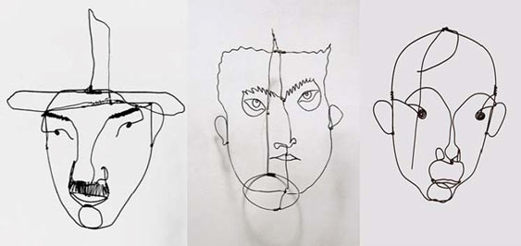

Project Requirements:
You will be constructing an Alexander Calder inspired wire sculpture. This will be a self-portrait assignment. You will need to use a photograph of yourself to model your sculpture from. You will start by practicing contour line drawing. This will help you define the shape of your sculpture. Using a variety of lines, construct your sculpture using the finalized contour line drawing as a guide.

Wire Self-portrait Sculpture Rubric | Student Evaluation (Circle one) | Teacher Evaluation
Meets Requirements:  - Student successfully created a sculpture using contour line  - Sculpture is representative of the artist that created it  - A variety of line was used (twisted, zig zag, coiled, etc.) | Needs Work …... Strong  1 2 3 4 5 | Creativity:  /50
Pieces of wire used (circle one):  The goal is to have one continuous line. The fewer cuts you make the better.  - pieces used | 4-6 pieces used | 7-10+ pieces used |  | Pieces of wire:  /10
Level of effort/attitude:  - Worked hard every class and used tools/materials correctly  - Focused on work and good craftsmanship  - Project is turned in on time | Needs Work …... Strong  1 2 3 4 5 | Effort/attitude:  /50
Craftsmanship:  - Evidence of hard work and quality of skill is apparent  - Problem solving was demonstrated in manipulating the wire to represent a photograph  - Wire is successfully secured, form is stable and isn’t falling apart | Needs Work …... Strong  1 2 3 4 5 | Craftsmanship:  /50
Final Teacher Evaluation:

Final Grade: /160 Points

