Sign Language Contour Drawings
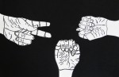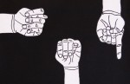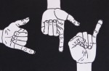

Objectives:
Students will be able to improve their ability to draw from observation.
Students will be able to define, identify and create a contour drawing.
Students will be able to demonstrate a high level of craft.

Process:
- Practice the contour drawing process (this will take a couple of days).
  - Move your eyes at the same speed as your pencil
  - If your eyes are moving, your pencil should be too, If your eyes stop your pencil should too.
  - Follow both edges and ridges of your hand (outside and inside lines)
  - Leave your modeling hand in the same position the entire time
  - Move slowly, Be patient
- Select the three different sign language letters.
- Draw several versions of each sign on white drawing paper.
- Select the best version of each sign.
- Trace all lines with black marker and cut each one out.
- Mount cutout hands on black construction paper.
Contour Hand Drawing Rubric | Student Evaluation (Circle one) | Teacher Evaluation
Creativity:  - Final image is based on three letters of the ASL alphabet  - Placement of hands on black paper is interesting or unique | Needs Work …... Strong  1 2 3 4 5 | Creativity:  /25
Level of effort/attitude:  - Worked hard every class  - Focused on work and good craftsmanship  - Had a positive attitude towards drawing | Needs Work …... Strong  1 2 3 4 5 | Effort/attitude:  /25
Craftsmanship:  - Evidence of hard work and quality of skill is apparent  - Drawing is clear and neat | Needs Work …... Strong  1 2 3 4 5 | Craftsmanship:  /25
Final Teacher Evaluation:

Final Grade: /75 Points

