Personal Still Life Drawing
Advanced Studio Drawing

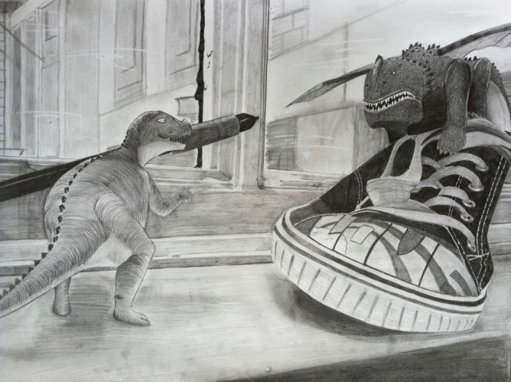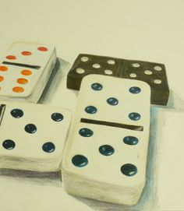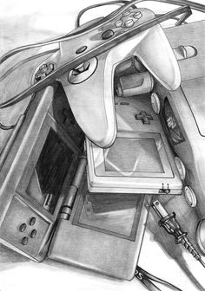

Objective:
Students will be using observational drawing skills to draw from life. Direct observation is a skill that is important to understanding what you are looking at and drawing!
  - Create an interesting composition using eye movement and placement
  - Develop skills in shading using a variety of materials… blending stump, finger, tissue, etc.
  - Show a full range of values from dark to very light
  - How are you going to push the medium to make this image exciting/interesting to the viewer?

Requirements:
  - Arrange at least three objects with special meaning to you in to an interesting composition.
  - Students must pay close attention to detail when describing the object/image up close… think about what it would look like if you used a magnifying class!
  - 12X18 or larger paper with your choice of medium.
  - Before you get your good paper, I would like to see some sketches for your final idea and layout. Since it is a close up of an object, think about engaging the edges of the paper and the possibility of little background space.

