Nature Inspired Linocut Printmaking
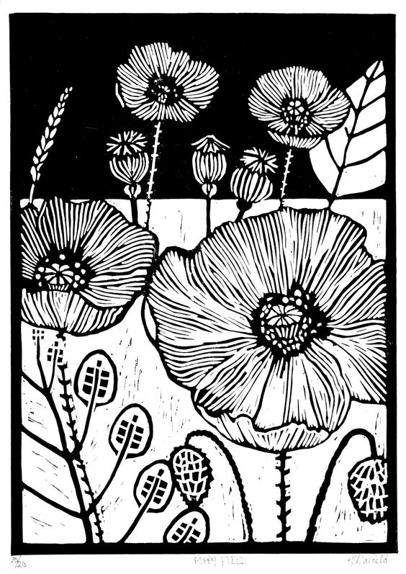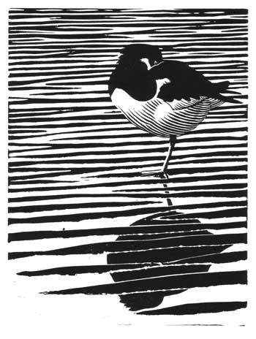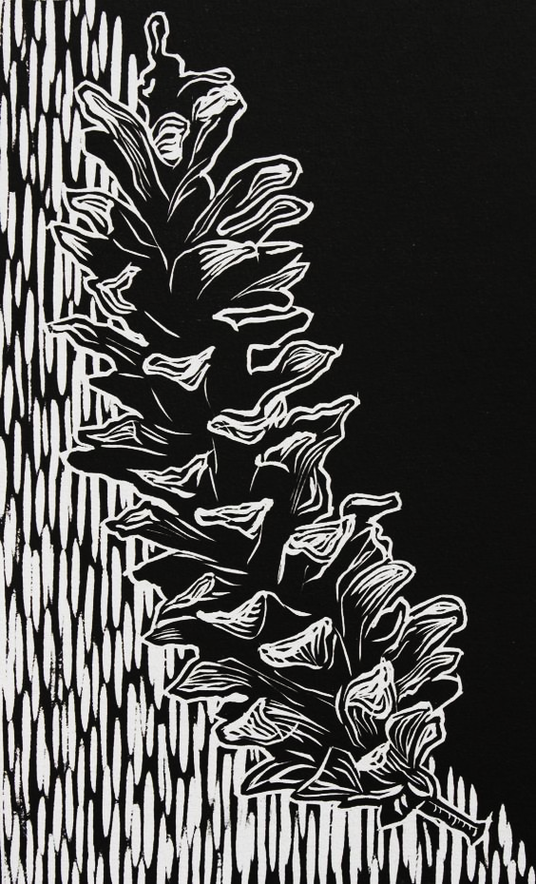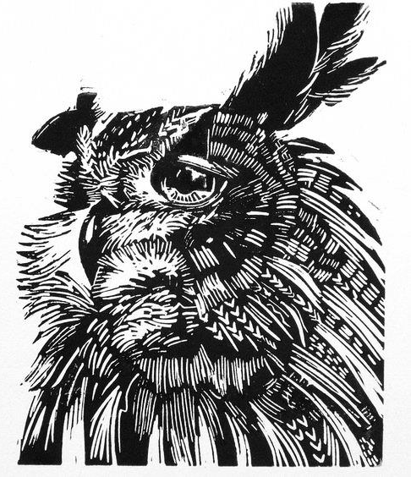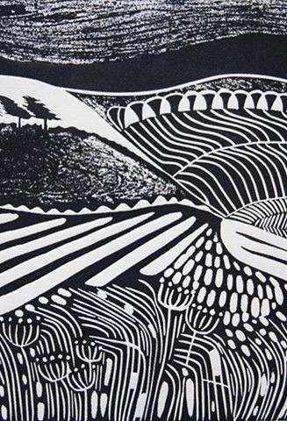
Objective:
Create a strong and dynamic composition inspired by nature.
Create an image with a high level of contrast.
Create a balanced image that incorporates the use of a variety of line and textures.

Process:
- Use your personal reference images, your imagination, or multiple images from online or from magazines to create a composition that emphasizes balance and contrast.
  - If using magazine or internet images, remember you must make significant changes to the original composition.
- When you have a completed composition use sharpie marker to color in any black areas. This will become your image.
- Use a pencil to color the back of your image. Place your drawing over your piece of linoleum and trace your lines with a sharp pencil or pen.
- Use sharpie to go over your transferred image on the linoleum block.
- Carve your image by removing the grey (uncolored) parts of your block.
- Print at least three copies of your block.
Line:
A line is an identifiable path created by a point moving in space. It is one-dimensional and can vary in width, direction, and length. Lines often define the edges of a form. Lines can be horizontal, vertical, or diagonal, straight or curved, thick or thin.
Texture:
Texture is the perceived surface quality of a work of art. It is an element of two-dimensional and three-dimensional designs and is distinguished by its perceived visual and physical properties. Use of texture, along with other elements of design, can convey a variety of messages and emotions.
Balance:
Balance refers to the feeling of equilibrium or stability of a work of art. There are three types of balances: symmetrical, asymmetrical and radial.
Contrast:
The arrangement of opposite elements (light vs. dark colors, rough vs. smooth textures, large vs. small shapes, etc.) in a piece so as to create visual interest, excitement and drama.

