Art I - Monochromatic Self Portrait Paintings
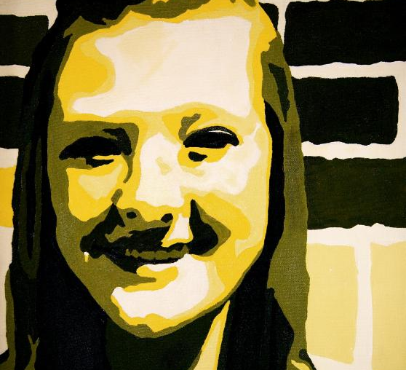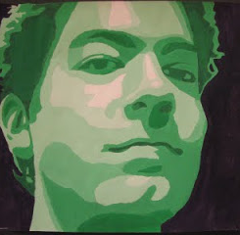
Students will learn how to posterize an image in Photoshop and then use that image for a monochromatic self portrait painting with a contrasting color background.
Objectives:
Students will be able to posterize an image in Photoshop
Students will be able to develop portrait to show mood/feelings through color
Students will develop skills in painting
Students will be able to create a scale of 5-7 values
Students will be able to demonstrate the use of contrast

Monochromatic Self Portrait Painting Rubric | Student Evaluation | Teacher Evaluation
Creativity  - Creative/unique facial expression  - Thoughtful composition/cropping of photo | Needs Strong  Work  1__2__3__4__5 | Creativity:  /50
Effort/Attitude  - Used class time effectively  - Worked hard/took project home if necessary  - Turned project in on time | Needs Strong  Work  1__2__3__4__5 | Effort/Attitude:  /50
Craftsmanship  - Broad range of values represented  - Value changes in painting represent the value changes in your source photograph  - Face was accurately traced or drawn on to canvas  - Paint is evenly applied, no areas of thin application | Needs Strong  Work  1__2__3__4__5 | Craftsmanship:  /50
Final Teacher Evaluation:

/150 points

