Endangered Animal Image Selection
- Go to Google images and search for an image of the endangered animal that you chose. This should be the same animal that you researched in the lab for the writing portion of the assignment. Be sure to consider the composition and clarity of the source image. You will use this image to create a drawing for your print.
- When you have found an image you like, click view Full-size image.
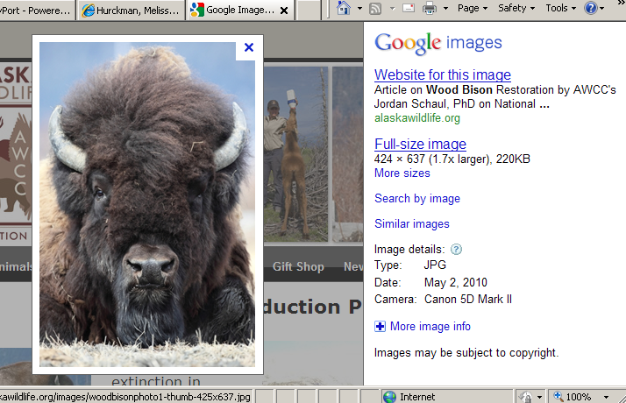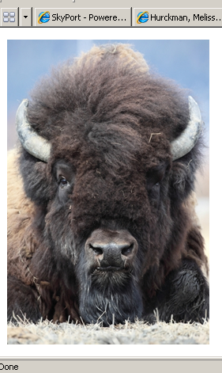
You should see a screen with only your image on it.

- Drag the full-size image to the desktop.
- Drag the file (your photo) to iPhoto.
- In iPhoto, change your photo to black and white.
click on edit > Effects > B&W
- Save your photo so you can access it again if you lose it.
- Print one copy. Select image size 5X7”

