Illustrated Dictionary Pages
Advanced Studio Drawing
- This art project was inspired by the very awesome art of Kristy Patterson. She has a blog at Flying Shoes Art Studio with tons of her artwork on it. Much of her art is centered around beautiful illustrations on old discarded dictionary pages. This approach to her art is intriguing to me because it shows the complexities and beauty of seemingly ordinary objects. There is a layer of depth and authenticity that is brought in by the aged and textured dictionary page background.

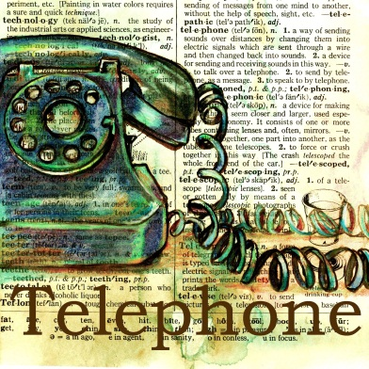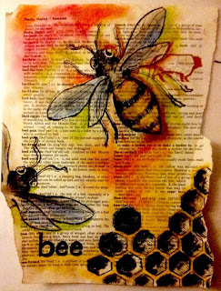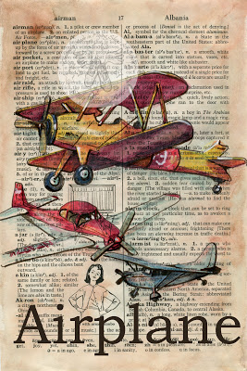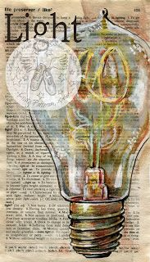

Materials:
- Old dictionary to tear out your pages from
- Soft pastels
- Colored pencils (for details)
- Ink pens (for outlines and details)
- Glue sticks
- Black construction paper (to glue your pages onto when finished)

Process:
- Attain an old dictionary
- Have students tear out pages and decide on the word they'll be illustrating.
- Brainstorm layouts and ideas
- Lightly sketch in pencil
- Outline with ink pen
- Color with soft chalk pastel or color pencils (need translucency)
- When it's complete, use a glue stick to glue the dictionary page onto some black construction paper to give it better stability.

Illustrated Dictionary Pages Planning Sheet

