Illustrated Alphabet
Advanced Studio Drawing

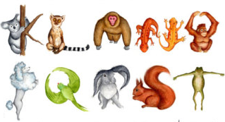
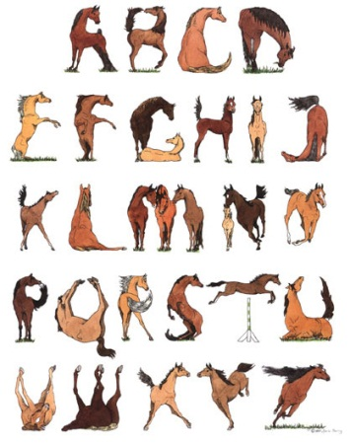

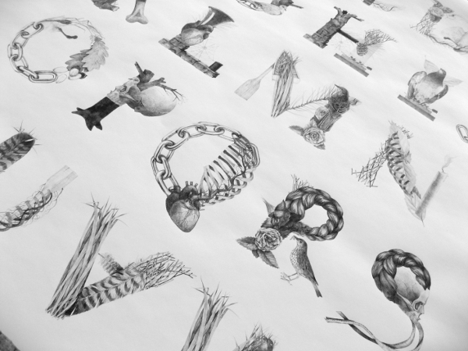

Objective:
Create an illustrated alphabet using one theme for all 26 letters. I do NOT want to see “A is for Apple” or “Z is for Zebra.” Instead, I want to see the individual letters created to match your theme. The examples above are great examples. They used horses, animals, and the desert as the theme of their alphabets.

Possible Mediums:
Pencil
Pen and Ink
Water Color
Colored Pencil

Process:
- Choose a theme
- Create a rough draft of each letter on the practice sheets of newsprint or drawing paper
- Lightly grid out your large paper so that all letters fit evenly on your paper. You will be creating one large composition, similar to the horse example above. It will end up looking like a poster.
- Draw one letter in each box in the medium of your choice
- Erase all grid lines, sign, and turn in

Evaluation:
You will be graded on creativity, your ability to keep a consistent theme, attitude/effort, and craftsmanship

