Art I: Grid Drawing and Values Project
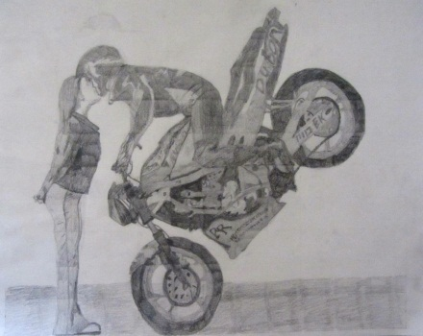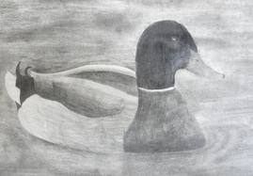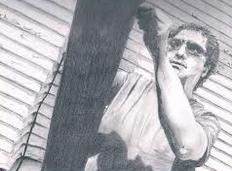
Using a grid is a helpful way to enlarge or reproduce a picture. It aids the artist in the placement of the different elements that compose the picture. By working with a grid, you will have an easier time getting the proportions correct. I have laid out the procedure in seven steps on the back of this page.
Please choose something more difficult than you would normally try to draw freehand because the grid system will help more than you may realize. No line drawings or cartoon characters!
Helpful Terminology:
Value: Element of art that deals with the lightness or darkness of something. This depends on how much light a surface reflects.
Contrast: To place and arrange values or colors so as to set off or bring out noticeable differences.
Highlights: Small white areas that show the surfaces of the subject that reflect the most light.
Shadows: Shaded areas in a drawing. They show the surfaces of the subject that reflect the lease light. They are used to create the illusion of form (three-dimensional reality).
Materials:
- Original image to enlarge
- Clear plastic grid (optional)
- Masking tape
- Drawing paper (12x18 or larger)
- Ruler
- Eraser
- Blending stump
- Calculator
- Samples of grid drawings

Steps for Creating a Grid Drawing
Step 1: Choose an image to enlarge. This can be a photograph, a picture in a magazine, a CD cover, etc. Please pick something smaller than 5X7” or crop a larger image this size. No cartoons or line drawings as this exercise is also to help you gain practice shading and using different values.
Step 2: Grid the original in one of two ways.
- Use your plastic sheet grid and place it over the image you will be drawing. Use masking tape along grid lines to isolate only those grid squares you will be drawing and number the squares along the top and the side. OR…
- Draw your own grid directly on the original image. This method allows for the ability to make smaller sized squares in areas that have more detail. Instead of numbering the squares, record the measurement of each line from the left edge.
Step 3: Use the Size Determination flow chart to help you decide what size to make the squares for the grid. The minimum paper size you may use is 12X18”. You must have at least 24 squares.
Step 4: Measuring from the top left edge of one side of the paper, make tick marks along this edge of the paper indicating where the edges of the squares will be. Then do the same for the bottom of the paper starting at the bottom left edge of the paper. Now do the left and right sides of the paper the same way. All four edges of the paper should have tick marks now.
Step 5: Use a 2B pencil to lightly draw the grid pattern on your white paper by simply connecting the tick marks. The number of squares shown on your original should match the amount drawn on your drawing paper (you may have extra squares that we will cut off.
Step 6: Begin sketching the outlines of major objects in your original square by square with a 2b pencil. Put it together like a puzzle. Once it is sketched out, begin adding values with the other pencils. You may choose to use blending stumps if desired.
Step 7: When you are finished, sign and date your work in the lower right corner and complete a rubric. Attach your project, original, and rubric with a paperclip then turn it in to be graded.

Determining the size of your grid drawing boxes

______inches ______ inches
Length of paper Width of paper
(longest side) (shortest side)

Divide by Divide by
Number of boxes Number of boxes
along the longest along the shortest
side of original side of original
Equals Equals

Write the smaller of the two
Above numbers in this box

Now, look for a decimal less than or equal to the number in the last box. The fraction conversion next to it is how large you should make your boxes.
0.500=1/2” | 1.125-1 1/8” | 1.750=1 ¾” | 2.375=2 3/8
0.625=5/8” | 1.250=1 ¼” | 1.875=1 7/8” | 2.500=2 ½
0.750=3/4” | 1.375=1 3/8” | 2.000=2” | 2.625=2 5/8
0.875=7/8” | 1.500=1 ½” | 2.125=2 1/8” | 2.750=2 3/4
1.000=1” | 1.625=1 5/8” | 2.25=2 ¼” | 2.875=2 7/8
Art I: Grid Drawing and Values Project Rubric
Project Requirements:
- The student will create a grid drawing based on an original image of their choice.
- Students will use a wide range of value in their finished drawing.
- Finished drawing should be at least 12X18” in size.
Grid Drawing and Values Project Rubric | Student Evaluation | Teacher Evaluation
Creativity:  - Interesting and complete composition | Needs work Strong  1 2 3 4 5 | Creativity:  /100
Effort/attitude:  - Worked diligently every class  - Focused on work, strived for perfection, and good craftsmanship | Needs work Strong  1 2 3 4 5 | Effort/attitude:  /50
Craftsmanship:  - Evidence of hard work and quality of skill is apparent with use of pencil values  - Artwork was carefully executed and matches original image | Needs work Strong  1 2 3 4 5 | Craftsmanship:  /50
Final Grade/ Teacher assessment:

/200
Student Assessment Grade: ____
Why?

