Art I – Clay Pattern Dishes
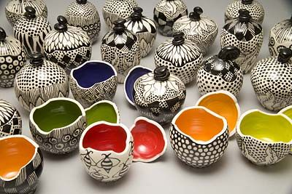

Project Requirements:
Students will use a table top wheel to construct a small bowl or dish using coil construction. The bowl must be at least four inches tall. Students will use various clay tools to smooth the inside and outside of the bowl so it doesn’t appear that the bowl was built with coils. After construction, we will apply black underglaze. We will then scratch designs onto the outside of the bowl. After the bisque firing, we will choose a contrasting color to glaze the inside of the bowls with.

Clay Pattern Dishes | Student Evaluation (Circle one) | Teacher Evaluation
Creativity:  - Pattern or motif used on outside of bowl is creative and unique  - Shape of the piece reflects that of a dish or bowl | Needs Work …... Strong  1 2 3 4 5 | Creativity:  /25
Level of effort/attitude:  - Worked hard every class and used tools/materials correctly  - Focused on work and good craftsmanship  - Assisted in group/table clean-up and also cleaned up individual spot at the end of class | Needs Work …... Strong  1 2 3 4 5 | Effort/attitude:  /50
Craftsmanship:  - Evidence of hard work and quality of skill is apparent  - Bowl is properly constructed (slip/score) and glazing was carefully executed  - Coil seams are well blended/smoothed  - Bowl is at least 6 coils or 4 inches tall | Needs Work …... Strong  1 2 3 4 5 | Craftsmanship:  /75
Final Teacher Evaluation:

Final Grade: /150 Points

