Clay Monster Design
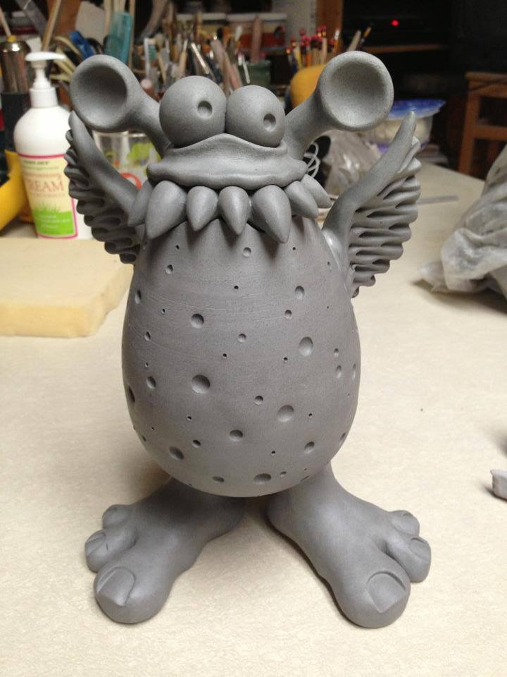
Face: It must have eyes and a mouth.
Expression: Make your monster be happy, sad, angry, or grinning. This is the most important aspect to your monster. It gives it character.
Texture: What does your monster have for it’s skin? Scales, fur, moles/dots all over or something else? If you don’t want texture for skin, you can put clothing on the monster or give it arms.
Legs/Feet: The monster must be able to stand. As for feet they can wear sneakers, have claws, or toes. Your monster could also have tentacles.
Optional Items: Arms, wings, tail, ears, nose or horns are all optional.
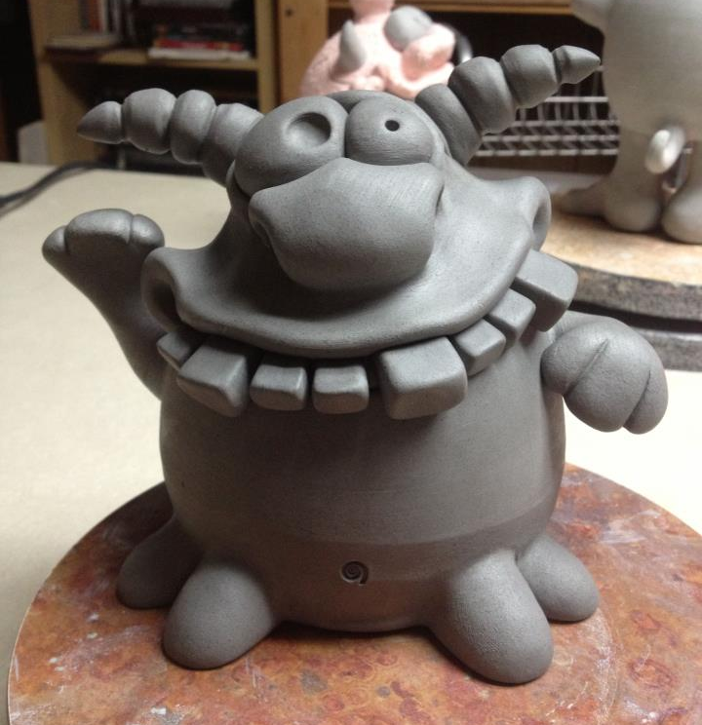
A monster can look scary or cute, but you can not copy an original design!
You must come up with your own.
If you like the idea of an existing monster you can incorporate a part of it into your design but the finished product must be original to you!

