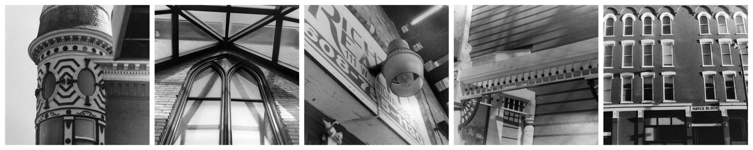
Photography: Architecture
Due Date: ______________________

12 photos: Architecture of Downtown Janesville
At least 6 photos should be detail shots!
For the first part of this shooting assignment you will need to make a trek to downtown Janesville. Look carefully and observe the intricate adornments of the many historic buildings Janesville has to offer. You may choose to concentrate on a single architectural element or shoot the building from many different angles and vantage points. Downtown Janesville also offers a few contemporary structures that might interest you in your quest for interesting and creative photo compositions. Get close – really see the building. Look for interesting and unique ways to showcase the architecture of downtown Janesville. At least 6 photos should be close ups of the details of buildings.

12 photos: Architecture of your Home
At least 6 photos should be detail shots!
For the second half of this shooting assignment you will need to capture the details of the exterior your home. This is your opportunity to make your dwelling stand out. You may live in a “boring old apartment” or a plain house, but I want to challenge you to find interesting details to photograph. At least 6 photos should be close ups of the details of your home. Think of patterns in brick or siding, interesting fencing or railings, etc.

Photography: Architecture
Due Date: ______________________

12 photos: Architecture of Downtown Janesville
At least 6 photos should be detail shots!
For the first part of this shooting assignment you will need to make a trek to downtown Janesville. Look carefully and observe the intricate adornments of the many historic buildings Janesville has to offer. You may choose to concentrate on a single architectural element or shoot the building from many different angles and vantage points. Downtown Janesville also offers a few contemporary structures that might interest you in your quest for interesting and creative photo compositions. Get close – really see the building. Look for interesting and unique ways to showcase the architecture of downtown Janesville. At least 6 photos should be close ups of the details of buildings.

12 photos: Architecture of your Home
At least 6 photos should be detail shots!
For the second half of this shooting assignment you will need to capture the details of the exterior your home. This is your opportunity to make your dwelling stand out. You may live in a “boring old apartment” or a plain house, but I want to challenge you to find interesting details to photograph. At least 6 photos should be close ups of the details of your home. Think of patterns in brick or siding, interesting fencing or railings, etc.

