Advanced Photography: Selective Developer Print
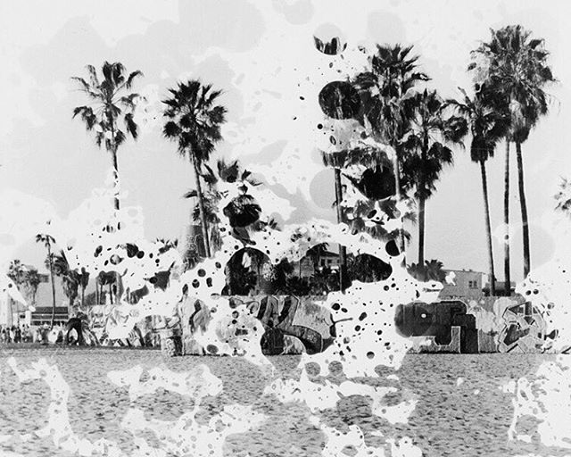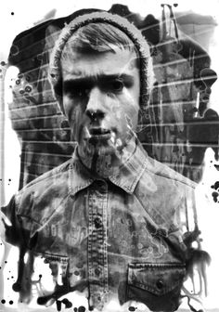
Use this alternative darkroom technique to create interesting 5x7 photograph. Instead of submerging your entire print in the developer, you will creatively and selectively apply the developer to your exposed photo paper.
Possible Tools:
Paintbrushes
Foam brush
Eye dropper
Sponge
Your hands **Be sure to wash your hands well after!

After you have applied the developer, you will proceed with the rest of the regular chemicals (stop bath, fixer, water wash)

You will mat your finished photograph and turn it in to the turn in box.

**This is a messy process! Please do this over the large sink or in an empty tray. Please clean up after yourself!

