Nature Inspired Pewter Castings
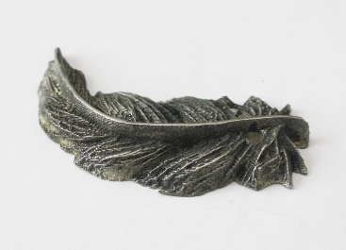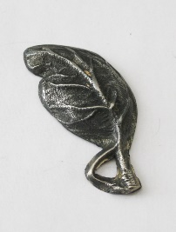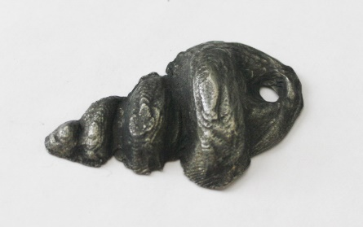

Project Requirements:
- Students will investigate and practice the art of pewter casting.
- Students will design and create a pewter casting representative or inspired by nature using the casting method.
- Final cast pewter piece will be attached to a painted wooden box
Pewter Casting Rubric | Student Evaluation (Circle one) | Teacher Evaluation
Meets Requirements:  - Student successfully created a 3-dimensional pewter casting  - Casting represents/was inspired by nature  - Final piece of cast pewter is attached to a wooden box | Needs Work …... Strong  1 2 3 4 5 | Creativity:  /50
Level of effort/attitude:  - Worked hard every class and used tools/materials correctly  - Focused on work and good craftsmanship  - Project is turned in on time | Needs Work …... Strong  1 2 3 4 5 | Effort/attitude:  /50
Craftsmanship:  - Evidence of hard work and quality of skill is apparent  - Pewter casting is properly filed and finished  - Wooden box is neatly painted | Needs Work …... Strong  1 2 3 4 5 | Craftsmanship:  /50
Final Teacher Evaluation:

Final Grade: /150 Points

