Abstract Name – Line and Composition
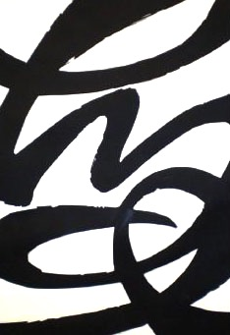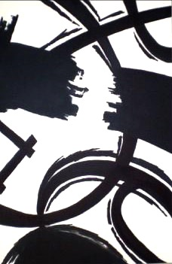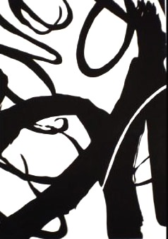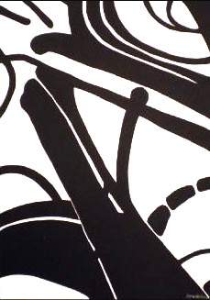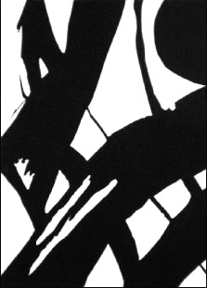
Objective:
Create a strong and interesting composition using a variety of line types and weights.
Create an image with a high level of contrast.

Process:
- Use your viewfinder to find an interesting composition within your pre-drawing. Whenever you see a strong composition, trace it in the viewfinder.
- Choose your strongest composition and cut it out from your pre-drawing.
- Begin drawing your composition onto your final drawing paper. At this point, you are welcome to make small changes to your source image to enhance the composition. You may free hand or use a grid to transfer your image.
- Use black sharpie to create a bold, high contrast image.
Types of Line Variations:
- Length – Lines can be long or short
- Width – Lines can be thick or thin
- Texture – Lines can be rough or smooth
- Direction – Lines can move in any direction, such as vertical, horizontal, or diagonal.
- Degree of Curve – Lines can curve gradually or not at all, become wavy, or form spirals.
Composition:
- Overlap – Objects should overlap, not touch
- Crop – Objects should interact with/intersect the edge of the paper
- Rotate – Tilted objects create a dynamic composition
- Focal Point – Give the viewer something to focus on
- Off Centering – Avoid placing objects in the center of the composition

