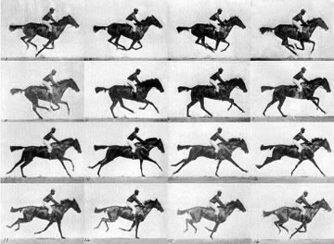 | Title:  Sallie Gardner at a Gallop  Photographer:  Date: | Why were these photos commissioned by Leland Stanford?
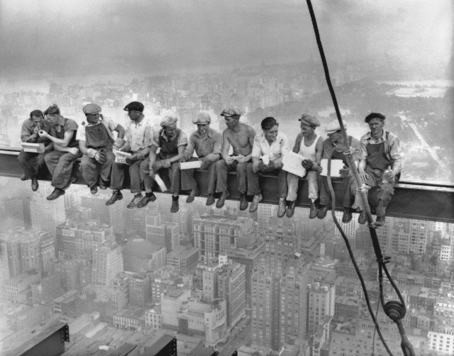 | Title:  Lunch atop a Skyscraper  Photographer:  Date: | Was this photograph staged or candid?  What building were these men constructing?
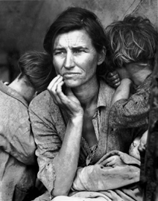 | Title:  Migrant Mother  Photographer:  Date: | What is the mother’s name?  List three facts about the photograph or the woman and children in it:
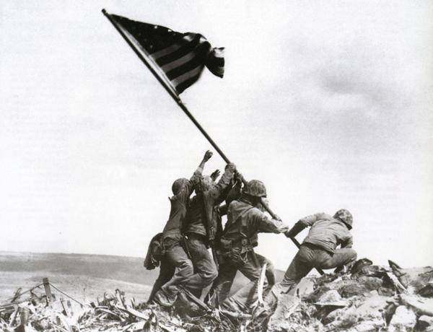 | Title:  Raising the Flag on Iwo Jima  Photographer:  Date: | What sculpture did this photograph inspire, and where is it located?
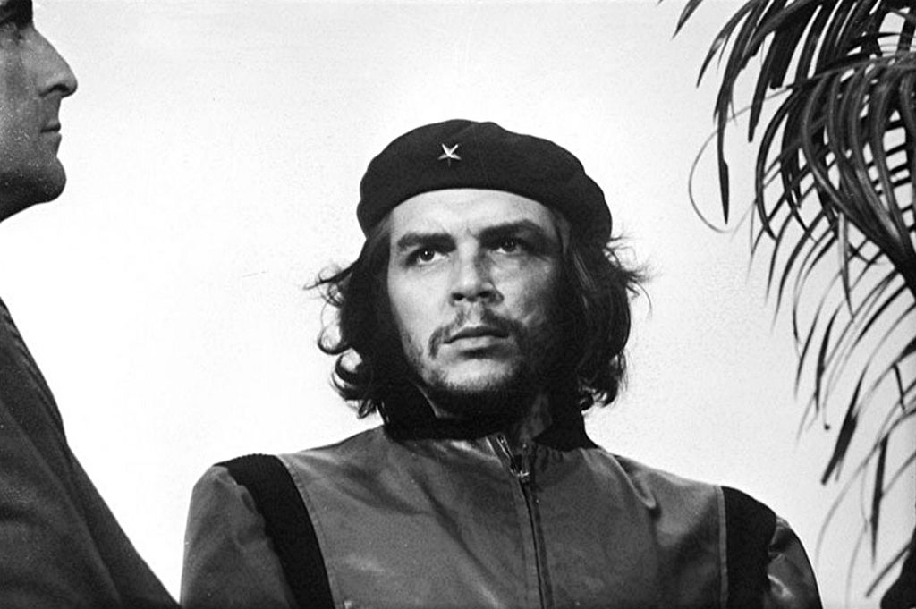 | Title:  Guerrillero Heroico  Photographer:  Date: | What did the photographer say he was first drawn to when taking this photograph?
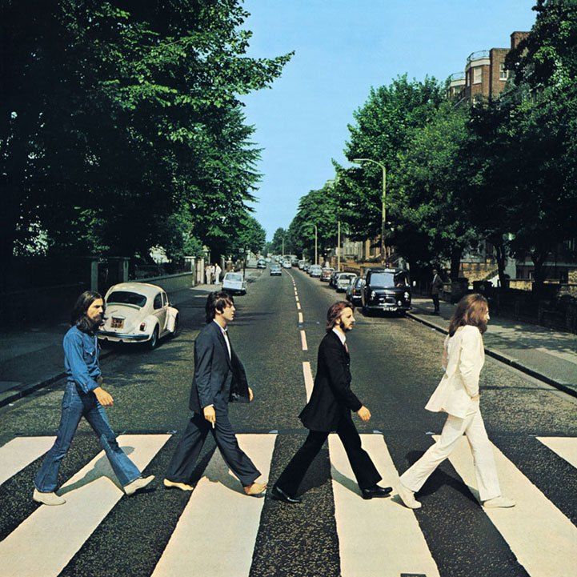 | Title:  Abbey Road  Photographer:  Date: | How many photographs were taken by the photographer during this shoot?  Why was this particular shot chosen for the album cover?
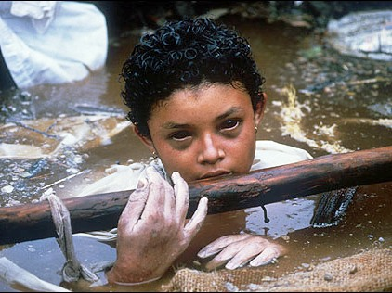 | Title:  Omayra Sanchez  Photographer:  Date: | Why do you think it was impossible for relief workers to rescue Omayra Sanchez?

