How To Solarize Black and White Photography - The Sabattier Effect
Updated on February 7, 2012

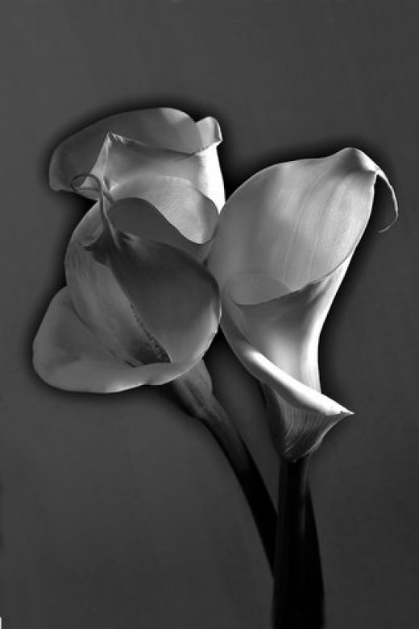
Solarization or the Sabattier Effect
Solarization is the process of re-exposing photographic paper during the development process. The result is an eerie silver image which contains light lines between the shadows and the highlighted areas.
Areas that have been exposed the least are affected the most during the re-exposure of the print. The darker areas or shadows on the prints show little change during the solarization process.
The Sabattier effect is a fairly easy process to achieve and can be done in a few easy steps.

The Process of Solarization
To begin the process, develop and agitate your paper normally. When the image begins to appear, remove the print from the developer and place it into a tray of water for about ten seconds. This will slow the development process.
The next step is to re-expose the paper to light. This exposure should last only about two seconds. The light source should be a low watt bulb, 15 to 20 watt, and should be three to four feet away from the print.
The final step is to put the paper back into the developer for the remaining development time. Complete the process of development using your stop bath, fixer and final wash.
In order to achieve the desired effects you may need to experiment with different exposure times. Two seconds is a good starting point, but you may need to vary the tone up or down depending on the print and the type of paper used.

Tips for gaining maximum results.
- Using high contrast papers will give you a more dramatic effect.
- Slow films are easier to work with since they require longer exposure time to develop.
- Since re-exposure effects the highlights, use a print with a lot of light areas to achieve the most dramatic results.
- Dilute your developer to twice the manufacturers recommendations.
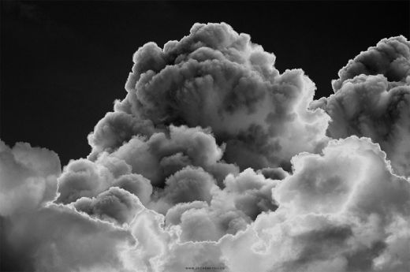

By spending a little bit of extra time in the darkroom and experimenting with exposure times, you can turn your black and white prints into dramatic works of art.
