How to make a Paper Negative Print
- Choose a print to make a negative of.
- Lay a piece of unexposed paper down with the shiny side facing up.
- Place the print your chose, face down, onto the unexposed paper.
- Place a sheet of plexiglass on top of the papers so they are sandwiched together flat.
- Press to ensure a good contact.
- Expose via your enlarger lamp for a couple of seconds (you will need to experiment - every negative is different).
- Process and dry the new image as you would any print.
If your prints are too dark, try a shorter exposure time. If your prints are too light, try a longer exposure time. Also, remember that paper negatives are not as sensitive as "normal" negative film. There will be a different look to your paper negative prints than "normal" prints.

You can also make paper negative prints using magazine images or text. Experiment with a combination of magazine images and your own photos!

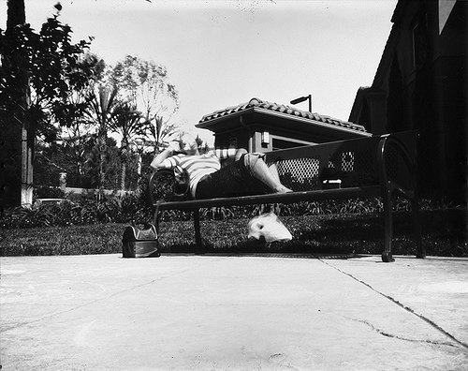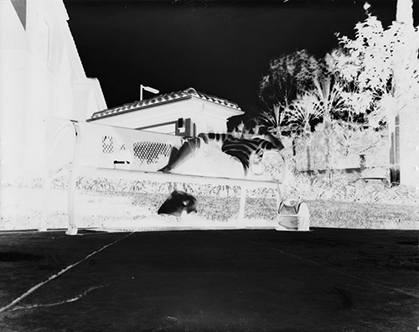
BEFORE AFTER

