Drawing II: Fruit Still Life Drawings/Colored Pencil Exercises

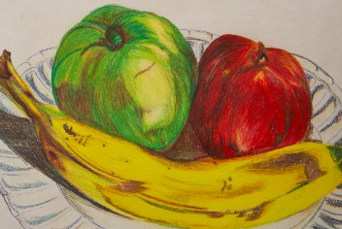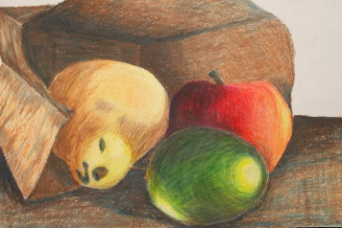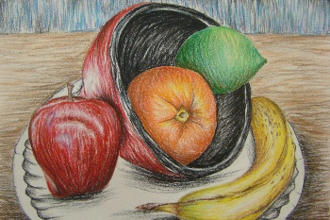
Directions:
- Set up the still life using at least two pieces of fruit. Consider your options and use a variety of fruit. Position the objects to make an INTERESTING composition.

- Complete the thumbnail sketch worksheet.

- Begin you first fruit still life by drawing a light pencil layout of the basic shapes. Consider drawing the shapes of highlights and shadows. Drawing A will be done with a technique of your choice (from your color grid worksheet). Drawing B will be done with a different technique of your choice (from your color grid worksheet). If you have time, you may complete Drawing C for EXTRA CREDIT with a 3rd technique of your choice.

- The set up for your fruit still life does not need to stay the same for each panel… it may change.

Drawing A Drawing B Drawing C
(Choice technique) (Choice Technique) (Extra Credit)
With Choice Technique

- Always remember to establish a background and a surface for your fruit to be placed… NO floating fruit!

Fruit Still Life Drawing - Grading Rubric
Requirements:
Student set up still life using at least two pieces of fruit. Students considered their options and used a variety of fruit…
No work or Somewhat interesting Awesome work
Poor idea/design idea/design
1 2 3 4 5
Design:
Fruit still life should have an interesting composition. Student shows and understanding of showing value with color (light to dark). Final design should be done to the highest quality. Drawings should include two of the three main techniques: smooth blending, hatching of your choice, and burnishing.
Created uninteresting/ Somewhat interesting/ Awesome/
Poor technique good technique great technique
1 2 3 4 5
Craftsmanship:
Student worked carefully and neatly to create a finished work of art that shows a high level of craftsmanship. Special attention should be given to color blending… OBSERVATIONAL COLOR!
Poor craftsmanship Average Great craftsmanship
1 2 3 4 5
Effort:
Student worked diligently, asked questions when unsure, used tools properly and safely, and turned completed project on time.
Misused most time Some time wasted Used all time wisely
1 2 3 4 5

I feel that I earned a/an _____ for my ______________________ fruit drawing because…

I feel that I earned a/an _____ for my ______________________ fruit drawing because…

I feel that I earned a/an _____ for my EXTRA CREDIT ______________________ fruit drawing because…

Teacher Evaluation Grade: _____________

