Crushed Can Triptych
Advanced Studio Drawing

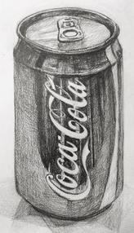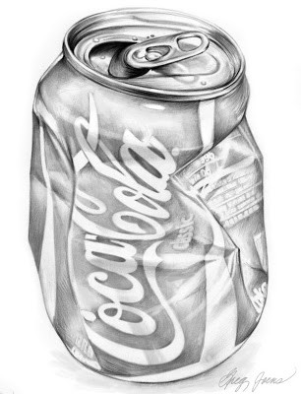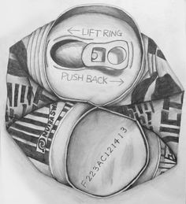

Objective:
Create a series of three drawings using an aluminum can.
The 1st drawing will be the can, completely intact.
The can will be moderately crushed for the second drawing.
For the 3rd drawing, you will completely crush the can.

*You will need to choose a can. If you can not get one, I will provide one for you

Possible Mediums:
Pencil
Colored pencil

Evaluation:
You will be graded on completion, use of value, accuracy, and overall craftsmanship.

