Creative Value Scale Drawings
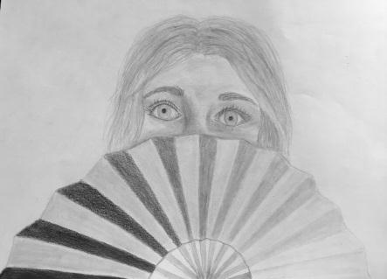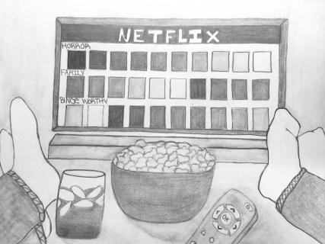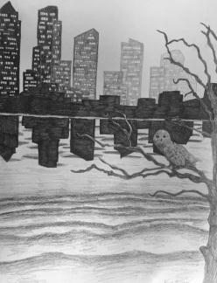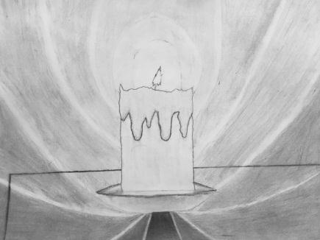

Objectives:
Students will improve their understanding of value as an art element
Students will be able to define, identify and successfully create a value scale
Students will be able to demonstrate value in a creative way
Students will be able to demonstrate a high level of craft

Value:
The degree of lightness or darkness in a color; the relation of light and shade in an artwork. Value can be used with color as well as black and white.

Creative Value Scale Drawing Rubric | Student Evaluation (Circle one) | Teacher Evaluation
Creativity:  - Final drawing is unique and creative, not a copy of someone else’s artwork  - Ten step value scale is successfully incorporated into the final drawing | Needs Work …... Strong  1 2 3 4 5 | Creativity:  /25
Level of effort/attitude:  - Worked hard every class  - Focused on work and good craftsmanship  - Had a positive attitude towards drawing | Needs Work …... Strong  1 2 3 4 5 | Effort/attitude:  /25
Craftsmanship:  - Evidence of hard work and quality of skill is apparent  - Drawing is clear and neat  - Ten step value scale is easily recognizable in the final drawing | Needs Work …... Strong  1 2 3 4 5 | Craftsmanship:  /50
Final Teacher Evaluation:

Final Grade: /110 Points

10 Step Value Scale (10 points):
Light Dark

