Art I – Clay Monsters
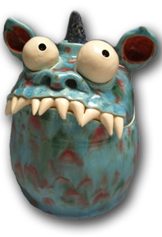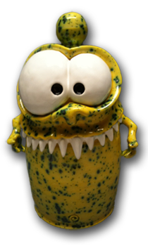

Project Requirements:
Students will hand build a clay monster from their own original design. The monsters must be properly constructed and hollowed out for firing. Students will glaze monsters.

Clay Monster Rubric | Student Evaluation (Circle one) | Teacher Evaluation
Creativity:  - Monster design is creative and unique  - Monster is original and not a copy of an example monster  - Monster includes additional features (hat, shoes, glasses, etc.) | Needs Work …... Strong  1 2 3 4 5 | Creativity:  /25
Level of effort/attitude:  - Worked hard every class and used tools/materials correctly  - Focused on work and good craftsmanship  - Monster meets all requirements (eyes, mouth, stands, has an expression, uses texture)  - Assisted in group/table clean-up and also cleaned up individual spot at the end of class  - Project is turned in on time | Needs Work …... Strong  1 2 3 4 5 | Effort/attitude:  /50
Craftsmanship:  - Evidence of hard work and quality of skill is apparent  - Monster is properly constructed  - Seams are well blended/smoothed | Needs Work …... Strong  1 2 3 4 5 | Craftsmanship:  /75
Final Teacher Evaluation:

Final Grade: /150 Points

