Art I: Radial Design Linocut
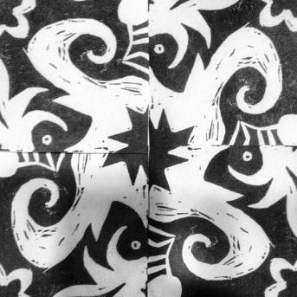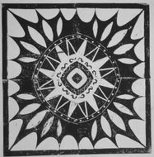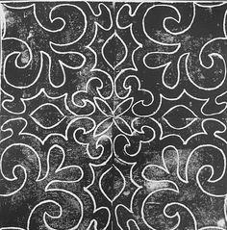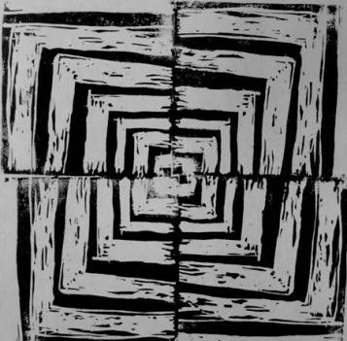
Project Requirements:
- Students will create a small design using at least three of the elements and principles of design
- Students will create at least three different layouts using their block
- Final project will be presented as a series of three with their best print matted
Radial Design Rubric | Student Evaluation | Teacher Evaluation
Creativity  - Design is interesting and complete  - At least three Elements and Principles were used and are justified below | Needs Strong  Work  1__2__3__4__5 | Creativity:  /50
Elements and Principles used:
Please list the elements and principles you used and explain how they work in your design

Level of Effort/Attitude  - Worked hard every class  - Focused on work and good craftsmanship  - Considered suggestions of other students and teacher | Needs Strong  Work  1__2__3__4__5 | Effort/Attitude:  /25
Craftsmanship  - Consistent, intentional use of correct materials  - Evidence of hard work and quality of skill is apparent  - Application of printing ink is applied evenly with an attention to consistency in printing.  - Final prints show high quality: no smudging or finger prints, straight on paper, etc. | Needs Strong  Work  1__2__3__4__5 | Craftsmanship:  /25
Final Teacher Evaluation:

/100 points

