Art I: Single Letter Monogram Linocut
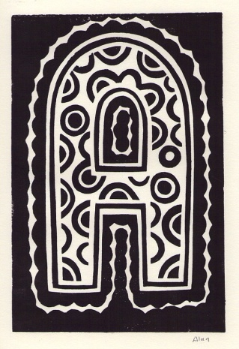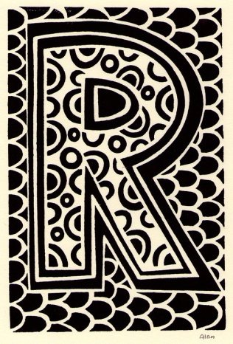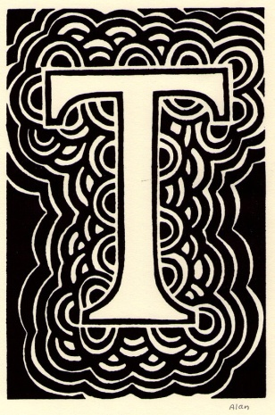
Project Requirements:
- Students will create a Single Monogram block on linoleum.
- Students will choose a letter and complete a planning worksheet.
- Students will use at least two different patterns in their Monogram.
- Final project will be presented as an edition of three, with the best print matted.
Single Letter Monogram Rubric | Student Evaluation | Teacher Evaluation
Creativity  - Final image is based on a letter of the alphabet  - Design is interesting and complete  - Design includes at least two patterns | Needs Strong  Work  1__2__3__4__5 | Creativity:  /50
Level of Effort/Attitude  - Worked hard every class  - Focused on work and good craftsmanship  - Considered suggestions of other students and teacher | Needs Strong  Work  1__2__3__4__5 | Effort/Attitude:  /50
Craftsmanship  - Consistent, intentional use of correct materials  - Evidence of hard work and quality of skill is apparent  - Application of printing ink is applied evenly with an attention to consistency in printing.  - Final prints show high quality: no smudging or finger prints, straight on paper, etc. | Needs Strong  Work  1__2__3__4__5 | Craftsmanship:  /50
Final Teacher Evaluation:

/150 points

