Art I: Zentangle® Drawings
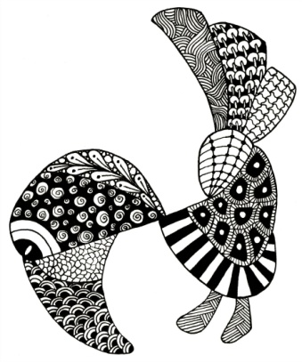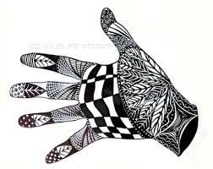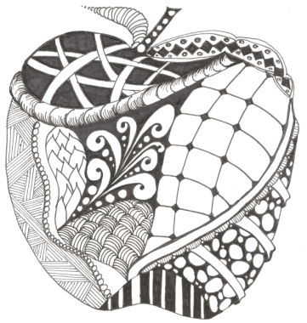
What is a Zentangle?
Zentangle - A Zentangle is an abstract drawing created by using repetitive patterns. It is usually structured within a certain shape. Drawing a Zentangle is entertaining, relaxing, and a great way to express yourself creatively.
String - A string is generally a random line drawn in pencil which creates an area within which you draw your tangles.
Tangle - In its verb form “tangle” means to draw a tangle. You tangle a tangle, and in that process create Zentangle art. In its noun form this word is used as a replacement for “pattern.”

For more information about the Zentangle process, go to www.Zentangle.com
Instructions:
- Complete your design matrix with patterns you could use for your Zentangle that use the elements and principles of design.
- Brainstorm different shapes you could use as the outline or frame of your Zentangle. You will want to choose something recognizable, like the images at the top of this rubric.
- When you have decided on a frame, draw it out on your paper using pencil.
- Draw in some “strings” to fit your “tangles” into. These lines can be random, or they can help make your frame into a recognizable object, like the eyes and feathers of the bird above.
- Choose at least 5 patterns from your design matrix to use in your Zentangle. Be prepared to tell me how the patterns demonstrate at least one of the elements or principles of design.
- Fill in your Zentangle with your tangles (patterns). Think about balance and unity when filling in your design. You should use at least 8 tangles in your completed image. At least 5 must come from your design matrix.
- When your Zentangle is complete, go over everything with black marker.
- Mat your finished image. Sign the bottom right hand corner.
- Complete the rubric and paperclip it to your finished work. Hand everything in.

Project Requirements:
- Students will create a Zentangle drawing using patterns created on their Elements and Principles design matrix.
- Students will demonstrate their knowledge of the elements and principles through the creation of tangles or patterns.
- Students will use at least eight different patterns in their drawing, and at least five must come from their design matrix.
Zentangle Drawing Rubric |  |  | Student Evaluation | Teacher Evaluation
Creativity  - Drawing includes at least 8 patterns/designs  - Zentangle is created within a recognizable outline  - Patterns are creative, varied, and unique |  |  | Needs Strong  Work  1__2__3__4__5 | Creativity:  /50
Level of Effort/Attitude  - Worked hard every class  - Work is complete |  |  | Needs Strong  Work  1__2__3__4__5 | Effort/Attitude:  /25
Craftsmanship  - Evidence of hard work and quality of skill is apparent  - Zentangle is neatly crafted  - Lines are well drawn and even |  |  | Needs Strong  Work  1__2__3__4__5 | Craftsmanship:  /50
Reflection
- Complete the table below
Pattern  (draw in box) | Elements and/or Principles Used | How/why?
Reflection:

/25
Final Teacher Evaluation:

/150 points

