Advanced Photography: Scratch Art Photo Overlay
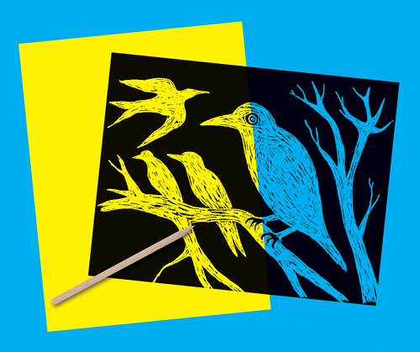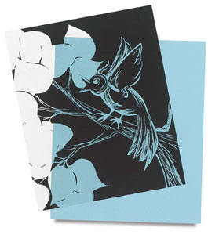

You will be printing a 5x7 photograph using a clear scratch art overlay. You will get a half sheet of scratch film to create a design on.
You will then choose a negative to print. In the darkroom, you will lay your completed scratch art overlay on top of your photograph. This will leave the black areas of your overlay unexposed or white on your final print.
You will mat this photograph and turn it in by the date listed on your calendar.

